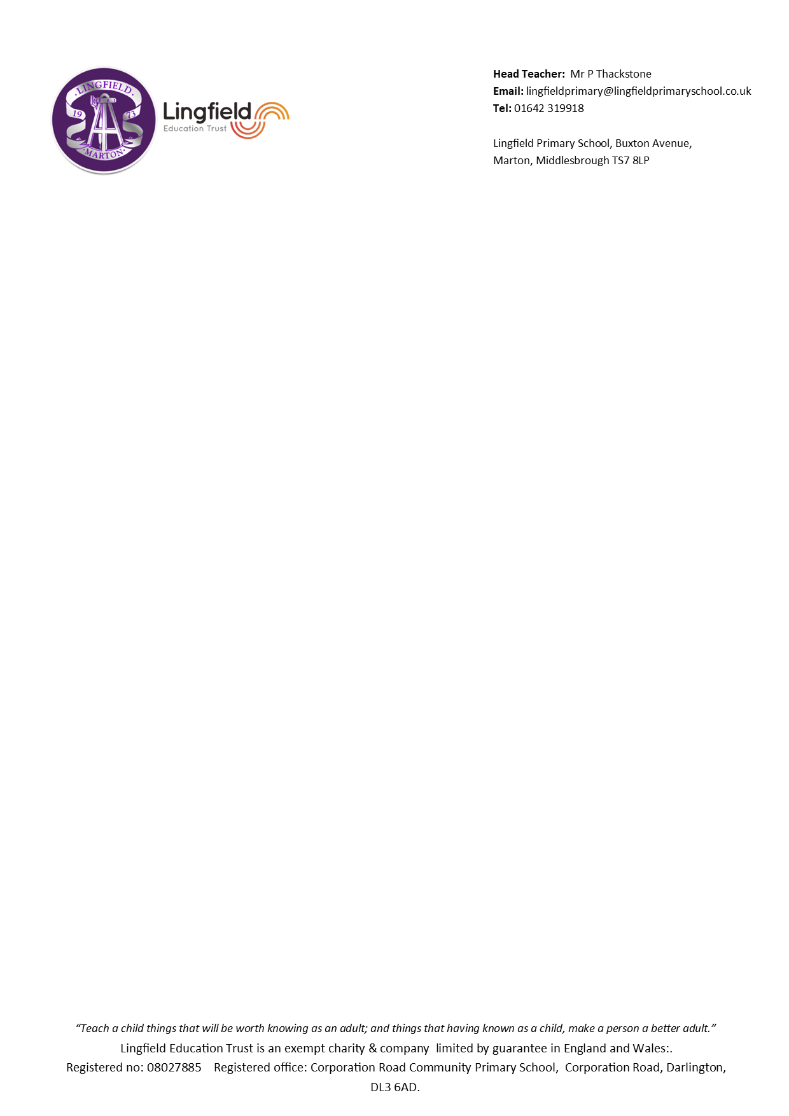
Dear Parents,

I am so pleased to be welcoming the children back to school following an exciting start to the year at Robinwood for many of the children. Now as Year 6 pupils, I hope to make their last year of school a memorable and enjoyable one, as well as supporting and moving them forward on their learning journey.

This term in Maths we will be covering a range of topics including exploring numbers to 10,000,000 and place value, order of operations, multiplication and division. It is important that the children keep their maths skills sharp, practising their times tables and number facts at home to develop speed and accuracy, using Times Table Rockstars can help with this.

In English, the children will work on reading skills and comprehension, we will start the year by reading Street Child, a historical novel based on the life of a young boy during the Victorian era. We will be writing non-chronological reports, diaries, descriptive settings and suspense narratives and finally, we will explore a courtroom close. We will be using a range of exciting books and extracts to help us develop our ideas! We will also continue to develop a wide range of grammar, punctuation and spelling skills and implement this into our work.

In History, we will study the Victorians, explore maps in Geography, and ask questions about challenges and religious beliefs in RE including ‘Does belief in Akhirah (life after death) help Muslims lead a good life and do Christian celebrations and traditions help Christians understand who Jesus was and why he was born?’ In science, we will learn how living things are classified into groups and develop our knowledge of electricity as we create a variety of different circuits. To develop our creativity, we will be creating monochromatic artwork focusing on self-portraits, creating light-up cards in DT and improving our vocal and instrumental range in music. In PE this term, we will work on hockey, tag rugby, fitness skills and gymnastics. Our computing work will focus on publishing, presentation, filmmaking, sound production and coding. We will cover work on internet safety, an important area which we will continue to reinforce throughout the year. In PSHE we will be thinking about what it means to be ourselves and how to celebrate difference and we will also develop our knowledge of a modern foreign language by studying French. By Christmas, I think we’ll all need a rest!

As the children will be sitting their SATs tests this year, weekly Maths and English homework will be given out. This will be set each Tuesday to be completed by the following Monday. Maths homework books will be given to the children which will help to reinforce the areas covered in lessons, developing fact fluency, skills practice and reasoning and problem solving. English homework will vary from week to week, but will include comprehensions, grammar, spelling and punctuation exercises and occasionally, writing tasks. Spellings will also be sent home each Tuesday and tested the following Monday.

In addition to this, children will need to read at home at least 4 times a week for at least 10 to 15 minutes; developing reading fluency and stamina is an important skill required in year 6. Reading Records will be collected in each Monday to reward children who read regularly, and to check reading materials and quantity of reading. Children can choose their reading books from the class collection, a book from home or one from the library.

PE will take place on Thursday and Friday afternoons. Children should come dressed in their PE kits on these days.

If you have any worries or concerns this year, please don’t hesitate in contacting me.
Thank you for your continued support.

Mrs Gamble

Head Teacher- Mrs N Padgett
Email- lingfieldprimaryschool@lingfieldprimaryschool.co.uk
Tel: 01642-319918

Lingfield Primary School, Buxton Avenue,
Marton, Middlesbrough, TS7 8LP

