
Lingfield Primary School Newsletter
February 2026

Message from Head Teacher

What a fantastic term it has been! I would like to take this opportunity to thank all our parents and carers for attending Parents’ Evening and for engaging so positively with our new SEND meetings. It has been wonderful to see school and home working so closely together to support our pupils in their growth and development. Strong partnerships between families and school truly make a difference.
As we look ahead to next term, there are some exciting changes on the horizon. We are beginning a revamp of our reception classroom over the upcoming holiday period, creating an even more engaging and inspiring environment for our youngest learners.

In addition, thanks to the funding we have received from Tesco, we will be developing our outdoor provision. During the Easter holidays, we will be looking for adult volunteers to help us with building and digging the foundations for these improvements. If you can support us, we would love to hear from you.

These are truly exciting times for our school community, and we look forward to continuing this journey together.
Thank you for your ongoing support.

Vaping
To help us keep our school environment safe and healthy for all pupils, we kindly ask that parents and guardians refrain from vaping anywhere on school grounds or near school entrances. Schools are designated smoke- and vape-free spaces to protect children from second-hand exposure and to model positive, healthy choices. Your cooperation sets a powerful example for our pupils and helps us maintain a clean, welcoming environment for everyone. Thank you for your support and understanding.

Water Bottles
Water Bottles in School — A Gentle Reminder
We would like to remind families that children should bring water only in their water bottles for the school day.
Recently, we have noticed an increase in juice and other drinks being brought into school. While we understand these can be enjoyed at home, water is the best choice during the school day as it helps children stay hydrated, focused, and ready to learn, without the added sugar.
Please ensure that your child’s bottle is filled with water only each day.
Thank you for your support in helping us maintain healthy habits across the school.

Fashion Accessories Reminder

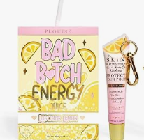
We would like to make parents and carers aware of a recent trend involving fashion accessories branded with P Louise and featuring slogans that are not appropriate for a school environment.
While we recognise that fashion trends can be popular with children and young people, items displaying unsuitable language or messaging do not align with our school values and expectations.
We kindly ask that these accessories are not brought into school. If seen, pupils will be asked to remove them and keep them safely in their bags until the end of the day.
Thank you for your continued support in helping us maintain a respectful and positive environment for all members of our school community.

Parking
We have had a few complaints recently regarding parking; therefore, we would like to offer a gentle reminder to all parents and carers to please park considerately when dropping off and collecting children from school.
We ask that you are mindful of residents, avoid blocking driveways, keep clear of junctions, and follow all parking restrictions to help keep everyone safe and traffic flowing smoothly.
Attendance
Attendance Matters – Being on Time
We have noticed an increasing number of pupils arriving late to school. It is the responsibility of parents and carers to ensure that children arrive on time each day, as punctuality is essential for both their own learning and the learning of others. When a child arrives late, it can disrupt the lesson in progress and impact the focus and progress of the whole class. If your child arrives after registration time, parents must accompany them into the school office and sign them in. This is a vital safeguarding procedure, as we cannot always guarantee that a member of staff will be immediately available to greet children at the entrance and ensure they enter the building safely. Allowing children to come into school alone after the gates have closed presents a safety concern. Over the next term, our signing-in process will be linked directly to our electronic registration system, meaning the information entered by parents will automatically transfer to the class registers. We appreciate your cooperation in ensuring your child arrives punctually and is signed in correctly, helping us to maintain a safe, orderly, and productive learning environment for all pupils.

Wrap Around – The Hideaway
IMPORTANT - If you require the wrap around provision, please could we ask that all parents book in via Arbor as we are getting near to capacity on some mornings and evenings and we would hate to turn anybody away. It is important for the safety of all pupils we are staffed accurately therefore booking in advance is essential.
Dogs on the school site
We would like to gently remind parents and carers that dogs are not permitted on the school site at any time, including at drop-off and collection.
This applies to all dogs, even when they are being carried. While we appreciate that many families have well-loved pets, this guidance is in place to support the safety, comfort, and wellbeing of all members of our school community.
Thank you for your understanding and cooperation.

World Book Day
Please be aware school will be celebrating world book day on the Friday 6th March in school and not the Thursday as published nationally. Children are invited to come into school dressed as their favourite book character, on this day. We are also delighted to be inviting parents and carers to join us on Friday 6th March 2026 for a special opportunity to share a book with your child. You are welcome to come along from 8:00am to 8:40am to enjoy a story together over breakfast whilst reading with your child. The event will be held in the school hall. This is a wonderful opportunity to spend some relaxed time in school, celebrate reading, and enjoy sharing a story together. We look forward to welcoming you.

Over the February half-term holiday, we are encouraging children to discover or create their favourite place to snuggle up with a good book. This could be a cosy corner of their bedroom, a den they’ve built, a quiet spot in the garden, or anywhere that makes reading feel magical.
We kindly ask you to take a photograph of your child reading in their chosen ‘reading nook’ and send it to school after the holiday. Please send your photographs to:
lingfieldprimaryschool@lingfieldprimaryschool.co.uk
These photographs will be proudly displayed around the school as part of our World Book Day celebrations.
To make things even more exciting, there will be a special prize for the most imaginative reading spot!

Comic Relief/Red Nose Day
We will be celebrating comic relief on Friday 20th March 2026 when children can come into school in non-uniform for a small contrition to the charity.

Coffee Morning
We held our first coffee morning last term, and it was lovely to hear parent views and how we could improve and reach out to more. I just wanted to continue to reiterate that my door is always open to answer any questions or concerns you may too. To continue to support the lines of communication further and to foster a positive dialogue within our school community, we invite you to join us on Wednesday, 24th June 2026, between 9.30am and 10.30am for a coffee morning hosted by Mrs Padgett and Mrs Jones. This is an excellent opportunity to chat informally with school leaders, with no agenda. Additionally, Mrs Jones will be available to discuss any individual SEND concerns you may have.
Thank you so much for supporting this wonderful cause and helping to spread joy this Christmas.
Newsletters

Just a reminder - Newsletter will be uploaded to the school website half termly to ensure you have the correct level of information. Any general reminders will now be sent out via Facebook to avoid overloading emails. The celebration of work and achievements will continue to be celebrated through Facebook too.
Dates for your Diary
These dates can change. In the event they do the next newsletter will be updated or a message will be sent home. We will add extra dates as they come up.
All performances will last approximately 1 hour.
Event | Date
Break up for half term | 20/02/2026
Return to school | 02/03/2026
School Book Fair – in the hall 8.15am and then 3.15pm | 04/03/2026 to 11/03/2026
World Book Day in School – Reading with breakfast | 06/03/2026 (from 8am int he hall)
Science Week in School | 9-13/03/2026
Individual Photographs all classes | 09/03/2026
Comic Relief/Red Nose Day – Non-Uniform Day | 20/03/2026
Reception & Year 6 class photos | 31/03/2026
Easter Egg Competition – more information to follow | 01/04/2026
Easter Egg Raffle Draw | 01/04/2026
Last Day of term (children last day in school) | 02/04/2026
Return to school | 20/04/2026
Autism Awareness and Acceptance Month – the children will be learning about this each week during the month | April 2026
Year 2 Bolton Castle Trip | 22/04/2026
Year 6 SATS week | 11-14/05/2026
Year 5 Life Centre Trip | 13/05/2026
Year 2 Class assembly - Parents invited | 20/05/2026 9am start in the hall
Walk to School Week – more information to follow | 18-22/05/2026
PD day (break up for the half term – children not in school) | 22/05/2026
Half term children off school | 25-29/05/2026
Sports week – all children to come dressed in sports wear each day | 29/06/2026 to 03/07/2026
Sports Day - Nursery | 02/07/2026
Sports Day - Reception to Year 6 | 03/07/2026
School Summer Fair – parents invited picnic style | 10/07/2026 from 1.30pm
Year 6 Leavers Trip | 13/07/2026
Year 6 Leavers Assembly | 17/07/2026
Break up for the summer – children in school last day | 17/07/2026

This is a copy of the school holidays for the academic year 2025/2026. PD days have not been confirmed yet.
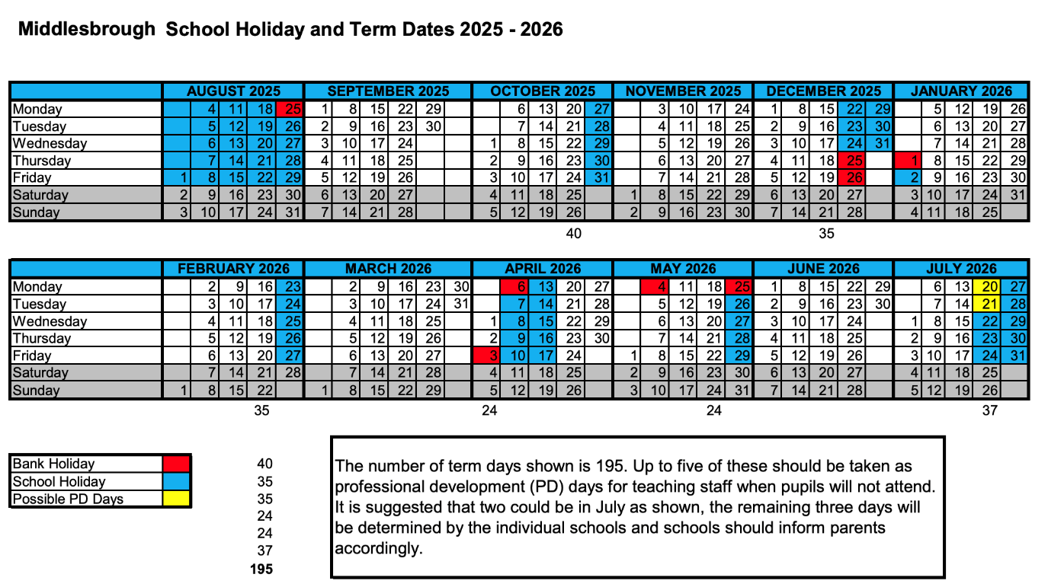
PD Days 2025-2026 for Lingfield Primary School will be...
1st September 2025
5th January 2026
22nd May 2026
20th July 2026
21st July 2026

