
Lingfield Primary School Newsletter
December 2025


Message from Head Teacher
As we come to the end of an incredible first year at Lingfield Primary School, I want to take a moment to reflect on what we’ve achieved together in 2025. This year has been nothing short of amazing, and that is thanks to the unwavering support from our staff, pupils, and you—our parents.

Starting a new chapter as a school is never easy, but your encouragement and partnership have made all the difference. Together, we’ve built a strong foundation, fostered a nurturing environment, and created a community where every child feels valued and inspired to learn. The progress we’ve made as a school is something we can all be proud of.

I truly believe we’ve come a long way this year—not just in academics, but in developing a culture of kindness, resilience, and ambition. Our pupils have shown incredible growth, and that is a testament to the teamwork between home and school.

Thank you for trusting us, supporting us, and walking this journey with us. I am excited for what lies ahead as we continue to grow and achieve even greater things together.
Wishing you all a joyful festive season and a wonderful start to the new year.

Packed Lunches/Fruit at break time
We have received updated guidance of EYFS children regarding choking hazards and how to support in school. These have been summarised below. Please could pupils who bring in a school pack lunch, who are also 5 years and under be aware of these. We are aware that cutting some fruits up early to put in packed lunches cause them to discolour, for example apples – school have apple slicer to support with this.

⭐ Early Years Choking Hazards — Simple Guide
(For babies and children under 5)
Early-Years-Choking-Hazards-Tab…

🍎 Fruit & Vegetables
- Remove pips and stones from fruit.
- Cut small round fruits (grapes, cherries, berries, cherry tomatoes) into quarters lengthways.
- Slice large or firm fruits (melon, apple) instead of cutting into chunks.
For very young children, grate, mash, or soften by steaming.
- Cut hard vegetables (carrot, cucumber, celery) into thin batons.
Consider grating/mashing for younger children.
- Peel skins on fruits/veg for easier swallowing.
- Cook firm produce (carrots, broccoli, apples) until soft.

🍗 Meat & Fish
- Cut sausages/hot dogs into thin strips; remove skins.
- Remove all bones from meat and fish.
- Cut meat into thin strips and remove skin/fat.

🧀 Cheese
- Serve grated or cut into thin, short strips (avoid large chunks).

🥜 Nuts & Seeds
- No whole nuts in school
- Chop or flake seeds before serving.

🍞 Bread
- White bread can become sticky and ball-shaped—a choking risk.
- Offer brown bread or toasted bread instead.
- Cut all breads (chapati, naan, etc.) into narrow strips.

🍿 Snacks & Other Foods (Avoid)
- No popcorn
- No marshmallows or chewing gum
- No boiled, hard, sticky, or gooey sweets
- No ice cubes
- No whole raisins/dried fruit under age 1 — always cut small
- Peanut butter is not allowed due to allergies in school
- No raw jelly cubes
We thought it would be useful tot share this with you, so you understand our guidelines.

Breaktimes
EYFS & KS1 children receive free fruit provide by the government. When serving this we follow the guidelines above and the children sit in class and eat this all together. If children prefer to, they can bring in their own fruit snack, but children will only be allowed fruit at breaktimes.

Water Bottles
Stay Hydrated the Right Way!
We encourage all pupils to bring a water bottle filled with water only to school. Water is essential for staying alert, focused, and healthy throughout the day. Please remember that juice is only permitted at lunchtime as part of a packed lunch and should not be brought into the classroom. This helps us maintain a clean learning environment and supports healthy habits for everyone. Thank you for your cooperation!

Attendance
Attendance Matters – Thank You!
We’d like to thank all parents and carers for being proactive in contacting the school when your child is absent. Your communication is vital—it helps us monitor attendance effectively and ensures we can support your child in returning to school and catching up on any missed learning. We are aware that many seasonal viruses have been circulating recently, which has understandably impacted attendance. Please continue to let us know promptly if your child is unwell so we can work together to keep everyone healthy and learning.
The Importance of Being on Time
we have noticed a growing number of children arriving at late. Arriving at school on time is essential for your child’s learning and wellbeing. The start of the day sets the tone for everything that follows—important instructions, routines, and early learning activities often happen first thing. When a child arrives late, they can feel unsettled, miss key information, and fall behind in their learning. Regular punctuality helps children feel confident, prepared, and ready to succeed.
If children arrive at school after the gates have closed, an adult must accompany them to the office to sign the register. This is essential for safety, as Mrs Martin may not be in the office at that time, and without signing in, staff may be unaware that the child is on site.

Early Arrivals
Children have been arriving on the school site early, we appreciate parents need to get to work but we wanted to make parents aware that children during this time are not supervised by staff. This means that if anything happens during this time, we cannot guarantee their safety.

We understand that some children come in early to help with jobs around the school, and this is fantastic. In these cases, staff are aware of their presence and they are supervised.

Please ensure that your child does not arrive too early unless arrangements have been made with a member of staff. Thank you for your support in keeping all our pupils safe.

Wrap Around – The Hideaway
If you require the wrap around provision, please could we please ask that all parents book in via Arbor as we are getting near to capacity on some mornings and evenings and we would hate to turn anybody away. This will allow school to ensure the correct number of staff are in place and that there is enough food for all the children attending.

Medication
As the winter season approaches, the prevalence of viruses tends to increase. Consequently, we kindly remind parents that all medication must be submitted through the school office, including items such as lockets, as we do not want them getting into the wrong hands or children chocking. Unfortunately, unprescribed medication, cannot be brought into school. Please consider that if a child cannot purchase it over the counter, it should not be sent to school. If you have any queries, please see Mrs Martin in the school office.
Staff
We would like to share some important news with you. After more than 22 years of dedicated service at Lingfield Primary School, Mrs. Peacock will be retiring from her role as Teaching Assistant in January.
Mrs. Peacock has been an invaluable member of our school community, supporting countless pupils with care and commitment throughout her time here. While she will be stepping down from her classroom duties, we are delighted that she will continue to be part of our team by helping during lunchtimes.
I am sure you will join me in expressing our heartfelt gratitude for her years of dedication and in wishing her the very best as she enjoys more time with her family.
Coffee Morning
We held our first coffee morning last term, and it was lovely to hear parent views and how we could improve and reach out to more. I just wanted to continue to reiterate that my door is always open to answer any questions or concerns you may too. To continue to support the lines of communication further and to foster a positive dialogue within our school community, we invite you to join us on Wednesday, 11th February 2026, between 9am and 10.00am for a coffee morning hosted by Mrs Padgett and Mrs Jones. This is an excellent opportunity to chat informally with school leaders, with no agenda. Additionally, Mrs Jones will be available to discuss any individual SEND concerns you may have.
Fundraising
We are thrilled to share that our recent school fair was a huge success! Thanks to your amazing support and generosity, we raised an incredible £1,500.

This fantastic amount will go directly towards upgrading resources in our Early Years provision, helping us create an even better learning environment for our youngest learners.

A huge thank you to each and every one of you for making this possible. Your involvement truly makes a difference!

Christmas Donations
A Heartfelt Christmas Appeal
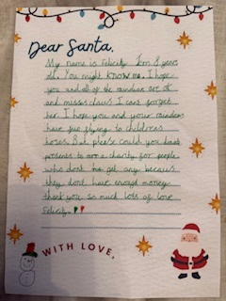
Recently, we received a touching letter from one of our pupils addressed to Santa. In her letter, she asked for something truly special—not for herself, but for children who may not receive anything this Christmas. Inspired by her kindness, we would love to help make this wish come true.
If you would like to get involved, we invite you to donate a gift for an underprivileged child in our local area. Gifts can be for any age from 0–18 years. Please bring them unwrapped and place them under the Christmas Tree in the school entrance hall.
Our School Ambassadors will deliver these gifts on 18th December 2025.
Thank you so much for supporting this wonderful cause and helping to spread joy this Christmas.
Nursery Door

Nursery Door Access Reminder
The nursery door opens at 8:30am. If you arrive after 8:45am, please be patient as staff will be teaching and may not immediately see you at the door.
If this happens, kindly enter via the school office so we can assist you promptly.
Thank you for your understanding and cooperation.

Newsletters

Newsletter will be uploaded to the school website half termly to ensure you have the correct level of information. Any general reminders will now be sent out via Facebook to avoid overloading emails. The celebration of work and achievements will continue to be celebrated through Facebook too.

Parent Survey

Thank you for taking the time to share your thoughts in the recent parent survey. Your comments are truly appreciated and play an important role in helping us grow and improve as a school.
I’m pleased to share a summary of the feedback we received along with the steps we’ve taken to address your suggestions. Your input has been instrumental in shaping positive changes across all areas of our school community. Please find a copy on our school website.
Lingfield Primary School (under Newsletters)
Dates for your Diary
These dates can change. In the event they do the next newsletter will be updated or a message will be sent home.
Please note changes or dates added are highlighted in yellow.
All performances will last approximately 1 hour.

Event | Date
Nursery Christmas Performance | 05.12.2021 @ 10am
Key stage 2 Christmas Performance | 09.12.2025 @ 9.30am
Key stage 1 Christmas Performance | 09.12.2025 2pm
Key stage 1 Christmas Performance | 10.12.2025 at 9.30am
Key stage 2 Christmas Performance | 10.12.2025 at 2pm
Nursery Christmas Party | 12.12.2025 am all invited
Christmas Dinner Day & Christmas Jumper Day – children can wear Christmas jumpers for the day | 16.12.2025
Reception, Y1 and Y2 Christmas party day – come to school in party clothes | 17.12.2025 am
Y3, Y4, Y5, Y6 Christmas party day – come to school in party clothes | 19.12.2025 pm
Last day of the term | 19.12.2025
PD Day children not at school | 05.01.2026
Children return to school | 06.01.2026
Year 3 swimming lessons | 12/01/2026 – 16/01/2026
Year 4 swimming lessons | 19/01/2026 – 23/01/2026
Parents invited to Maths play and stay session with out Maths lead | 23/01/2026
Ambassadors to Visit Hemlington Hall & Viewley Hill School | 02/02/2026
Coffee Morning with Mrs Padgett and Mrs Jones – all welcome | 11/02/2026 9-10am
Year 3 Pedestrian training | 13/02/2026
Break up for half term | 20/02/2026
Return to school | 02/03/2026

This is a copy of the school holidays for the academic year 2025/2026. PD days have not been confirmed yet.
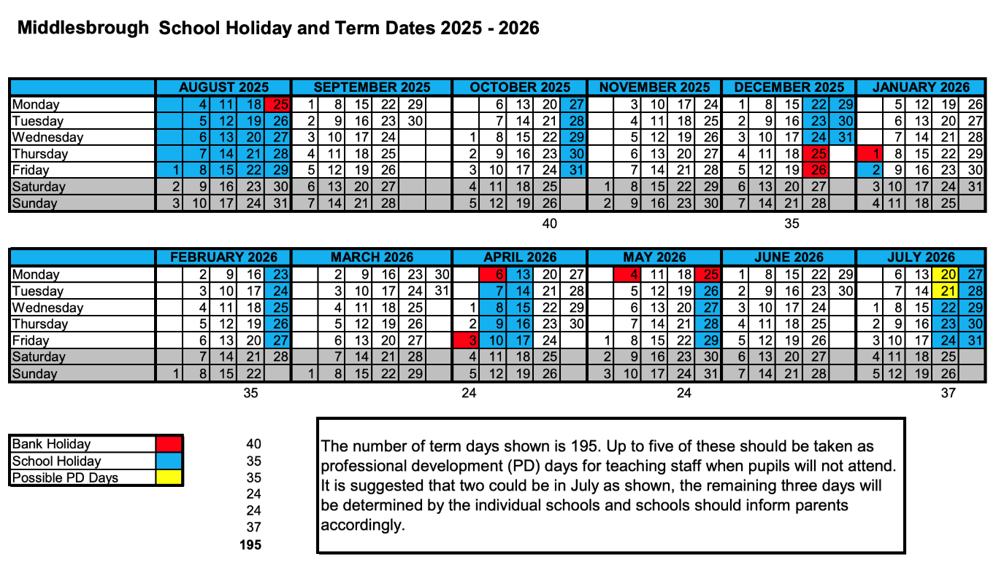
PD Days 2025-2026 for Lingfield Primary School will be...
1st September 2025
5th January 2026
22nd May 2026
20th July 2026
21st July 2026

