
Lingfield Primary School Newsletter
October 2025

Message from Head Teacher
I am pleased to share how remarkably well the children have settled into their learning journey this term. Walking around school, in and out of lessons, on the playground and in the dining hall it has been wonderful listening to their enthusiasm and engagement of lessons demonstrating a genuine curiosity and eagerness to explore new concepts. This is what school is all about! It has also been wonderful to celebrate the array of special events and accomplishments your children have experienced outside of school. These contributions not only enrich our classroom community but also allow us to foster a greater sense of belonging among the children. I kindly encourage you to continue sharing these exciting moments, as it brings a delightful sense of connection and celebration to our learning environment. Together, we can ensure that every child's achievements, both in and out of school, are recognised and valued. Thank you for your continued support and for being an integral part of our vibrant school community.

Packed Lunches/Fruit at break time
We would like to take this opportunity to express our appreciation for the healthy packed lunches you are providing for your children who are not on school meals. It is wonderful to see such consideration for their nutritional needs. As you know, fruits and vegetables play a vital role in maintaining a balanced diet, contributing to the overall health and well-being of our pupils.
In this light, we kindly request that if you choose to include grapes in your child's packed lunch, please ensure that they are cut in half, regardless of the child's age. Grapes, when left whole, are known to pose a choking hazard, which can lead to serious safety concerns during mealtimes at school.
Additionally, we would like to remind all parents to avoid products containing nuts, as we have of several pupils and staff members who suffer from severe allergies. By adhering to these guidelines, we can ensure a safe and healthy environment for all our children. Thank you for your continued support in promoting healthy and safe eating habits in our school community.

Attendance
I am pleased to report that individual attendance records are looking particularly positive this term. Your commitment to ensuring that your children attend school regularly has made a significant difference in their academic progress and personal development. Regular attendance is exceptionally important, as it not only enhances learning outcomes but also fosters social interactions among peers.
I would like to take this opportunity to extend my heartfelt gratitude for your continued support and collaboration. Your efforts in promoting the importance of education at home are invaluable. As we move forward, let us maintain this momentum by encouraging our children to prioritise their school commitments. Together, we can ensure that every child reaches their full potential.
Thank you once again for your dedication to your child's education.

Wrap Around – The Hideaway
We are delighted to announce the opening of our new wrap-around care building, which will enhance our provision for the Breakfast Club and After School Club. This exciting development reflects our commitment to providing high-quality care and support for your children.
To facilitate the move, we will be transferring all equipment on Friday evening, ensuring that everything is in place for the following week. As of Monday, please note that children attending the Breakfast Club and After School Club will be dropped off and picked up at the new bungalow located on-site, the same systems are in place at drop off and collection times.
Please could we kindly ask parents to refrain from bringing food from home to school for wrap around, due to severe allergies affecting some of our pupils and staff. Any exceptions can only be accommodated with prior discussion with Miss Davis, along with a copy of the food packaging for verification.
If you require the wrap around provision, please could we please ask that all parents book in via Arbor as we are getting near to capacity on some mornings and evenings and we would hate to turn anybody away. This will allow school to ensure the correct number of staff are in place and that there is enough food for all the children attending.

Medication
As the winter season approaches, the prevalence of viruses tends to increase. Consequently, we kindly remind parents that all medication must be submitted through the school office, including items such as lockets, as we do not want them getting into the wrong hands or children chocking. Unfortunately, unprescribed medication, cannot be brought into school. Please consider that if a child cannot purchase it over the counter, it should not be sent to school. If you have any queries, please see Mrs Martin in the school office.
Staff
I am pleased to announce the safe arrival of baby Noah, following Mrs Park's early maternity leave. Both mother and baby are doing well and enjoying precious family time together.
We are delighted to welcome back Mrs Shipp from her maternity leave on Monday 13th October. She will be returning on a part-time basis and will work in Year 2 alongside Mr Juckes, who was appointed on Tuesday. We extend a warm welcome to Mr Juckes, who is joining the Lingfield family.
Coffee Morning
We are aware that many of you are utilising WhatsApp groups to connect with one another, which is brilliant. I just wanted to let you know that my door is always open to answer any questions you have too. To support the lines of communication further and to foster a positive dialogue within our school community, we invite you to join us on Wednesday, 12th November, between 9am and 10.30am for a coffee morning hosted by Mrs Padgett and Mrs Jones. This is an excellent opportunity to chat informally with school leaders, with no agenda. Additionally, Mrs Jones will be available to discuss any individual SEND concerns you may have.
Trees
We would like to inform you that a tree survey has been completed, revealing that one of our lovely ash trees in the KS1 playground requires removal due to ash dieback disease. This work will be carried out by professionals in the coming months.
Parents’ Evening
Please book for your parents’ evening appointment via Arbor. Parents evening will take place on Monday 20th and Tuesday 21st November 2025.
Fundraising
Just a reminder of the fundraising event on Friday, 17th October 2025, to benefit the MND Association. If children want to particate in the event we do need the consent form completing, unfortunate if this is not received by school children will not be able to participate due to allergies/reactions.
Additionally, from 3.15pm, we will host a coffee and cake and sweet sale, with all proceeds directed to the MND Society. We would really welcome any donations of cakes and sweets to support this important cause. Thank you for your generous support.
Harvest Festival
We're excited to support Harvest Festival this year! We will be holding special assemblies in school in October. The school council would like to donate non-perishable food items or other essentials to support local charities. Your generosity can make a real difference in our community. Let's come together to help those in need! Please leave anything you can in the box in the school entrance.

Glow Disco

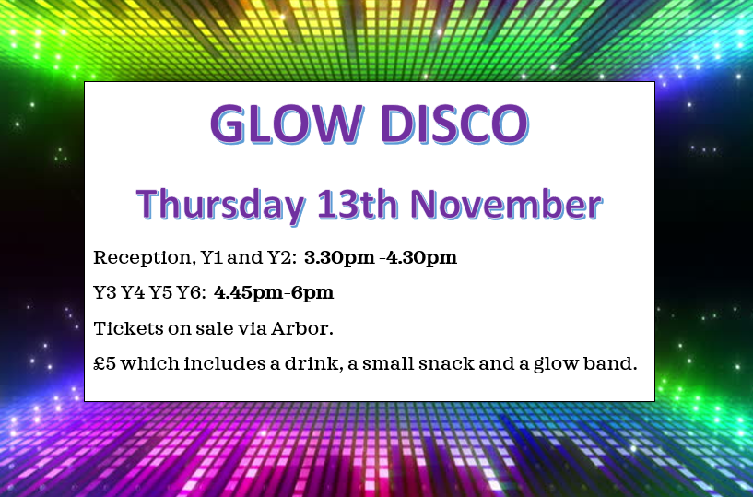
Dates for your Diary
These dates can change. In the event they do the next newsletter will be updated or a message will be sent home.
Please note changes or dates added are highlighted in yellow.

Event | Date
Year 5/6 Girls Tag Rugby Competition – children selected for this event will receive a letter | 13.10.2025
Year 5/6 Boys Tag Rugby Competition – children selected for this event will receive a letter | 14.10.2025
Parents Evening | 20.10.2025  21.10.2025
Harvest Festival in school for pupils  Non uniform day/ Halloween costumes  Break up for October half term (in school) | 24.10.2025
Return to school | 03.11.2025
Glow Disco | Reception to Y2 3.30pm to 4.30pm  Y3 to Y6 4.45pm to 6pm
Christmas Fair | 24.11.2025 3.30pm-5pm
Nursery Christmas Performance | 05.12.2021 times to be confirmed
Key stage 2 Christmas Performance | 09.12.2025 at 9.30am
Key stage 1 Christmas Performance | 09.12.2025 at 2pm
Key stage 1 Christmas Performance | 10.12.2025 at 9.30am
Key stage 2 Christmas Performance | 10.12.2025 at 2pm
Nursery Christmas Party | 12.12.2025 am all invited
Christmas Dinner Day & Christmas Jumper Day | 16.12.2025
Reception, Y1 and Y2 Christmas party day – come to school in party clothes | 17.12.2025 am
Y3, Y4, Y5, Y6 Christmas party day – come to school in party clothes | 19.12.2025 pm
Last day of the term | 19.12.2025
PD Day children not at school | 05.01.2026
Return to school | 06.01.2026

This is a copy of the school holidays for the academic year 2025/2026. PD days have not been confirmed yet.

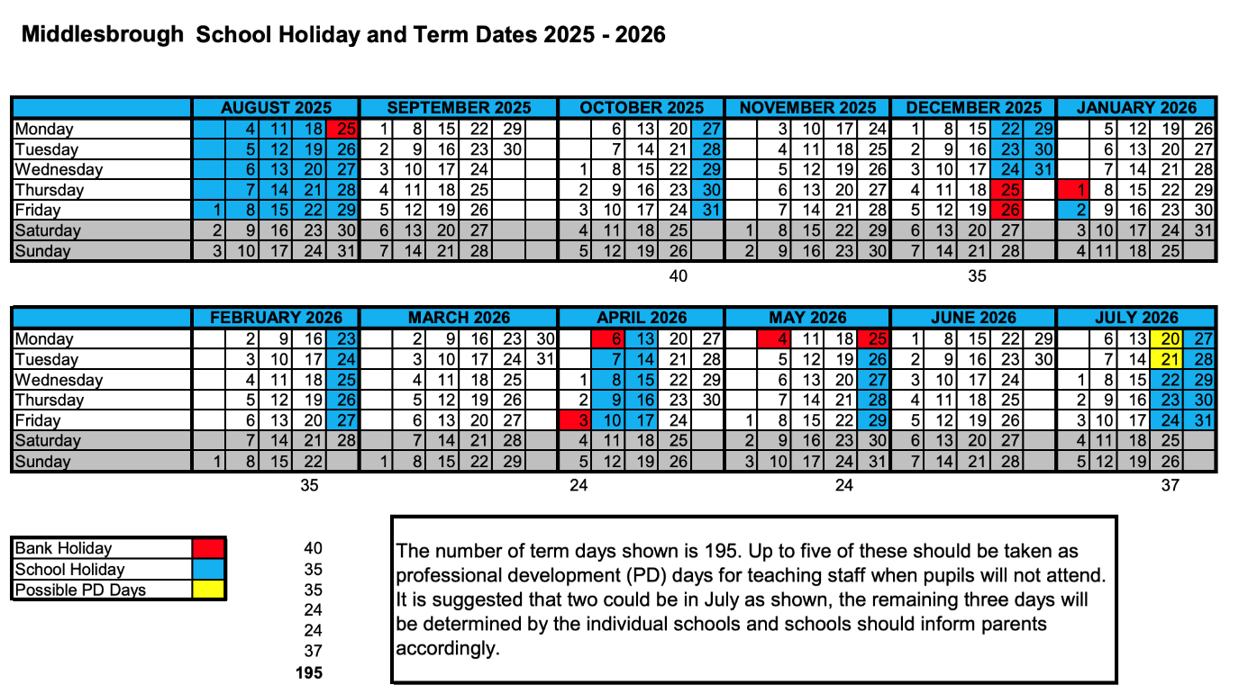PD Days 2025-2026 for Lingfield Primary School will be...
1st September 2025
5th January 2026
22nd May 2026
20th July 2026
21st July 2026

