

Lingfield Education Trust
Behaviour Policy

Policy Version Control
Policy type | Lingfield Primary School
Policy prepared by (name and designation) | Nicola Padgett  Head Teacher
Last review date | 17th October 2025
Description of changes | Autumn 2025 - New policy
Date of Board of Trustees approval | 3rd November 2025
Date released | 3rd November 2025
Next review date | Autumn 2026


Lingfield Primary School
Behaviour Policy 2025
Reviewed September 2025
Nicola Padgett

Overview
Our firm belief is that the best schools serve all learners — not just those who find it easy to comply. At Lingfield, we strive to be the very best school we can be for every child in our community, ensuring that all children receive what they need, rather than only what they are perceived to ‘deserve’.
We believe this is achieved through a foundation of kindness and strong, trusting relationships throughout our school. The connections between children and staff are central to bringing this vision to life.
Our school motto is more than just words; it shapes our culture and guides our actions every day.
“Great Minds Grow Here – Be the Best You Can Be” lies at the heart of everything we do at Lingfield Primary School.
Supporting this are our six core virtues, which are woven through our curriculum, policies, and daily practice.

Routine Matters
Children flourish when they have a sense of consistency and routine. For some, school provides the only source of this stability. Therefore, our behaviour approach includes clear routines and expectations that set a positive tone from the moment children and their families arrive at school.
These consistent routines and expectations are:
- Consistent arrivals (Detailed in appendix 1)
- Lingfield moving around school (Detailed in appendix 1)
- Lining up (Detailed in appendix 1)
- Constantly referring to our school rules
- Consistent reward and recognition
- Consistent adult language and approach to behaviour Individual classroom routines
- Individual classroom routines

Clear Rules and Associated Language Matter
We have three, simple school rules which encompass all aspects of school life. These are explicitly taught and they are displayed in all key areas (poster in appendix 2). These rules are:

- Show kindness
- Show Respect
- Try your best

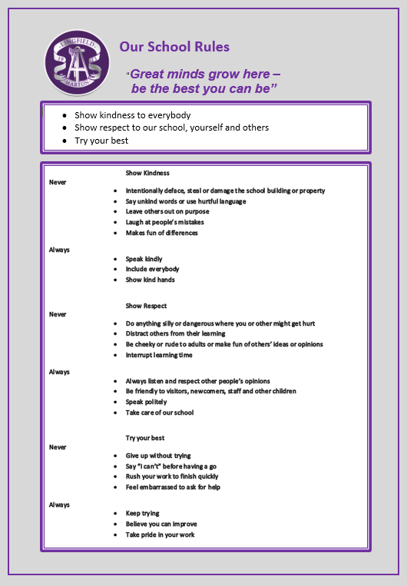
Rewards
Merits
Each pupil from Year 1 is issued a merit card, and upon completion, they are presented with a certificate in assembly as recognition of their sustained commitment to learning.

Merits can be awarded for:
- Doing the right thing
- Brilliant work and effort
- Recognition for following/displaying our school values

In addition, children can also gain a place on the star board for following the three school rules. This is our method of teaching the children our rules, quickly and in depth.
Above and Beyond Bands
We must recognise the children who go ‘Above and Beyond’ the school expectations. Children who stand out, at a particular time for doing something special and more than is expected to simply follow the rules of the school. When any adult in school sees a child do this, they must recognise it – and reward it, with an ‘Above and Beyond Band’. These bands are written on to say what was so amazing (so that parents and carers can see, as well as other staff) and who had awarded it. “Leon saw me drop all of my books – he ran from his football game to help me pick them up. He was so kind. Mrs Padgett☺”.

Individual children should not receive several of these each week; they are special and highly regarded. Staff should always have a supply to hand – they should be an immediate reward. Visitors are also shown the system at ‘check in’ – anyone can recognise excellence at Lingfield: a child receiving an ‘Above and Beyond Band’ from the visiting plumber, for helping to move some books in front of some pipes, without being asked may be something that the child may never forget.

Weekly Award Assembly
Pupil of the Week
On a Friday in whole school assembly, teachers recognise a child in their class who has worked exceptionally hard and followed the school rules. The children are rewarded with a certificate to take home. The children are proud of their awards and then they have their photograph taken and posted on our school ‘Facebook’ page.
Values Award
Each term, we focus on a specific school value. Every teacher will secretly nominate one Values Ambassador who best represents that value. Parents will be invited to attend a special assembly where the award is presented. The chosen children will proudly wear a star badge to show staff and visitors their achievement.

Headteacher Awards

The Headteacher recognises outstanding work and effort by awarding special stickers and certificates. This fantastic work is then celebrated and shared with our school community on Facebook.

It is important that no additional formal awards are created by staff, as consistency across the school is essential. Sweets should not be used as rewards. Staff should avoid creating individual ‘special rewards’ for children who find behaviour challenging, unless this has been agreed with the Headteacher (for example, following advice from an educational psychologist). Doing so can unintentionally reward inappropriate behaviour. Simple stickers for good participation or effort in a session are perfectly acceptable.

Consistency across the school is key at Lingfield Primary School.
Poor Behaviour Matters
In a primary school, children are not only learning to read, write and count – they are also learning to behave. As such, at times, most children will require their choice of behaviour to be checked or addressed.
Before this conversation happens, it is vital that the adult stops and considers:
- How would I speak to this child if their parent was on my shoulder?
- What would the best teacher in the world do?
- It is my professional responsibility to stay calm; I need to be mindful of my tone, body language and intonation.
- Children who struggle to behave take more time out of lessons – don’t give it to them in lessons too. Learning should not be impacted. Choose the time to speak to the child wisely.

At Lingfield Primary School, we have a clear, stepped approach to addressing a child who is not doing as we expect. In use of sanctions, children learn from experience to expect a fair and consistently applied punishment which differentiates between serious and minor offences.
Sanctions are applied consistently by all staff, but with the provision for flexibility to take account of individual circumstances.
Sanctions Procedure
We have an agreed system of sanctions which all staff must adhere to. Professional judgement is required regarding which step best reflects the most suitable sanction given for the behaviour displayed. Detention outside of school hours is not part of our agreed sanctions. In exceptional circumstances, depending on the nature of the offence, the sequence of sanctions will be bypassed resulting in fixed term or permanent exclusion.
All staff have the right to apply agreed sanctions up to and including Time Out C. More serious sanctions, such as playground exclusions or internal exclusions must be agreed in advance with a member of SLT.
As a general rule for minor and low-level behaviours the following sequence should be adhered to:
Classrooms utilise a visual behaviour tracking system represented by monster icons. This system operates on a three-step approach, consistent with the framework shown in the table below.

 | In Classroom | On Playground
Reminder | Remind the child that they are not following a school rules/Values. This is a subtle behaviour management technique and is a quiet and low-key reminder of expected behaviours. It should be given as a polite reminder. Walk away to give time for the child to correct their behaviour, without an audience. | Remind the child that they are not following a school rule. This is a subtle behaviour management technique and is a quiet and low-key reminder of expected behaviours. It should be given as a polite reminder. Walk away to give time for the child to correct their behaviour, without an audience.
Step 1 Warning | If the behaviour continues, calmly remind – again, personally, with the consequences made clear. At this point, the child’s monster will be moved down the classroom behaviour chart. This is not a ‘name and shame’ and should not be publicised to give notoriety – but the child needs to know that the stepped approach has started. | If the behaviour continues, calmly remind – again, personally, with the consequences made clear.
Step 2 Last Chance | Inform children that monster will be moved down again and this is their final warning. Children should be fully aware of what this means and the possible consequences of continuing with the behaviour. | Inform children that this is their final warning. Children should be fully aware of what this means and the possible consequences of continuing with the behaviour
Children can at any stage have their monster moved back you the chart, showing positive changes to their behaviours.
From now on, no more warnings. Action is taken and behaviour is recorded on CPOMS
Time Out A | - Child is sent to a designated area of the classroom or outside of the classroom  - Child spends 5 minutes sitting alone in order to reflect, calm down without causing disturbance  - Child’s behaviour is recorded on CPOMs  - Parents Contacted  For a regular offender at Time Out A (Regular = more than three times in two weeks) - Removal of treats/playtimes - Discussion with SLT to consider behaviour interventions | - Child is sent to a designated area of the playground  - Child spends 10 minutes sitting or standing alone in order to reflect, calm down without causing disturbance  - Child’s behaviour is recorded in playground Behaviour log and CPOMS  - Parents Contacted  For a regular offender at Time Out A (Regular = more than three times in two weeks) - Removal of treats/playtimes - Discussion with SLT to consider behaviour interventions
Time Out B | - Child is escorted to a designated colleague that is agreed in advance.  - Up to 1 hour working alone without causing disturbance  - Removal of some playtime  - Incident recorded on CPOMS  - Parents Contacted  For a regular offender at Time Out B (Regular = more than three times in two weeks)  - Discussion with SLT at SLT meeting - Involvement of SENCo  - Begin behaviour monitoring to identify triggers  - Parent meeting to agree support required - Consider recommendations from professional agencies  - Access to extra-curricular/ enrichment linked to improvement | - Child is escorted to a Senior Leader  - Removal of some playtime  - Takes place in HT/Learning Mentor office  - Incident recorded on CPOMS  - Parents Contacted
Time Out C | - Child is escorted to a Senior Leader (HT or DHT)  - One session or half a day working alone without causing disturbance  - Takes place in HT or with DHT  - Removal of playtime  - Incident recorded on CPOMS  - Parents contacted | Playground exclusion are for serious incidents, for example physical harm or aggression to another.  - Parents informed  - Recorded on CPOMS

Repair – to take place following any time out incident
It is the conversation about poor behaviour that changes it – not the punishment. Children need to know that if behaviour falls short of the standard expected by the school, that they will have to face it, during a ‘repair conversation’. This will be with the adult that imposed the time out or HT and not during lesson time – it should be at a lunch or playtime. If the staff member requires cover for this – it should be prioritised. This is the chance for the adult and child to discuss the behaviour that led to the time out and any possible consequence or ‘imposition’ of it.
The fact that this conversation happened – and any key outcomes, should be recorded on CPOMS, if the adult deems it appropriate (e.g. a child not paying attention twice, which is out of character for the child and leads to a time out and conversation would not need to be recorded, but if an issue is becoming to be a pattern, or is leading to clear actions for the child or an intervention, it should be recorded).
In this meeting, it is vital that the adult is transparent as to whether parents will be informed.
The key ‘Repair Conversation questions’ are below, however 5 is enough, and less for young children (those in bold are most suitable for EY / KS1):
- What happened?
- What were you thinking at the time? (How XXX were you at the time, out of 10?)
- What have you thought since?
- How did that make people feel?
- Who has been affected (hurt/ upset for KS1)?
- How have they been affected?
- What should we do to put things right?
- How can we do things differently in the future?

Repeated or Serious Behaviour
If a child displays a behaviour that has serious consequences for others, such as a physical or verbal attack, racism or homophobia, we recognise that not only does the child require the support from school (and potentially other professionals) to address these behaviours, but also from home. As such, if a child carries out a serious behaviour incident, the staff member dealing with the incident can choose to escalate the sanction to Time out B or C as appropriate. A telephone call home or discussion with parents at pick up about such incidents, or call parents and carers, is expected by all staff.
Issues will be monitored by SLT and any reoccurring incidents will be discussed if further interventions are required, further external options:
- Counselling
- Educational Psychologist
- Outreach Support from LA
- Support from Early Help
Extreme Behaviours
Occasionally, some children may behave in an extreme way which is out of character for them, or poses a serious risk to the child, others or the harmonious running of the school.
Unacceptable behaviours may be expedited quickly through our behaviour system to be dealt with by a member of SLT. If this occurs a focused meeting involving SLT and the staff members will be arranged to discuss what happened and will follow the repair approach. Behaviours may include:
- Violence (i.e. physical contact made with the intention to harm)
- Repeat or Extreme defiance/ rudeness to any adult
- Persistent taunting, teasing and bullying
- Stealing
- Repeated Spitting
- Repeated Swearing

All such incidents and SLT repair meetings will be recorded on CPOMS.
Tracking Behaviour
Each week, each class has a tracking sheet to monitor behaviours. This is a quick way to review low level issues and trends for cohorts and children. If a child is given a ‘Time Out’ – this is recorded and the brief reason noted on the back. If it is recorded on CPOMs, it does not need recording twice. Simply indicate there is a CPOMs record linked to the event. SLT review the tracking sheets each week to identify trends, CPD or individual children’s behaviours which are beginning to cause a concern.
Exclusion
When a child is excluded, for any length of time, they cannot be positively influenced by school; as such, it is not an approach taken lightly by the school. Importantly, however, a school must have procedures in place, by law, should the need or situation arrive. Our procedures are detailed within our Trust Exclusion Policy which is found here: https://www.lingfieldeducationtrust.com/trust-policies
Physical Interventions
Children should not require Physical Intervention unless they are posing an immediate risk to themselves, or others. As such, we have a full Physical Intervention Policy in place, based upon the best practice principles outlined in ‘Positive Environments, Where Children Can Flourish’ (OFSTED, 2018).
Behaviour in Our Community
Children who attend Lingfield Primary School are its ambassadors beyond the school day. As such, we would address inappropriate behaviour outside school if the following applied:
- The child was taking part in a school organised or a school related activity
- The child was on their way to or from school
- The behaviour could have repercussions in school
- The behaviour threatened another pupil of the school. Incidents outside school would be investigated fully and normal sanctions would be applied.

Parent and Carers
Parent and carers play a vital role in the management of pupil behaviour and have the right to know that their child is doing well or needs support. Parents are informed of good behaviour through our rewards systems – as well as the through the relationships that staff build with our families – catching parents on the yard, telephoning, emailing, via Facebook or using Marvellous Me are all appropriate ways to spread good news.
Equally if their child is behaving inappropriately at school, they must always be informed. It is preferable to inform the parent face to face about concerns, failing that a telephone call.
In cases of challenging behaviour, parents will be invited to meet with staff. At this meeting a school behaviour plan will be completed, including agreed Team Teach holds, if necessary, in line with the school Physical Intervention Policy.
Induction
Any new member of staff joining the school receives a copy and training on this policy.
Review
It is important that the school’s work with regard to behaviour is reviewed regularly – and by a range of stakeholders. Each year, staff, parents and children have the opportunity to review the success of the school approach, through discussion and questionnaire feedback. Annually, governors and school leaders review the policy in relation to this feedback. The policy also closely aligns to the Lingfield Education Trust Behaviour Principles, which can be accessed here: https://www.lingfieldeducationtrust.com/trust-policies
Signed: N.Padgett Headteacher
To be reviewed September 2026
Appendices
1 | Behaviour Blueprint
2 | Consistent Approach School Routines
3 | Our school rules
4 | De-escalation Techniques
5 | Pupil Behaviour, Positive Handling and Risk Assessment
6 | Class behaviour Log
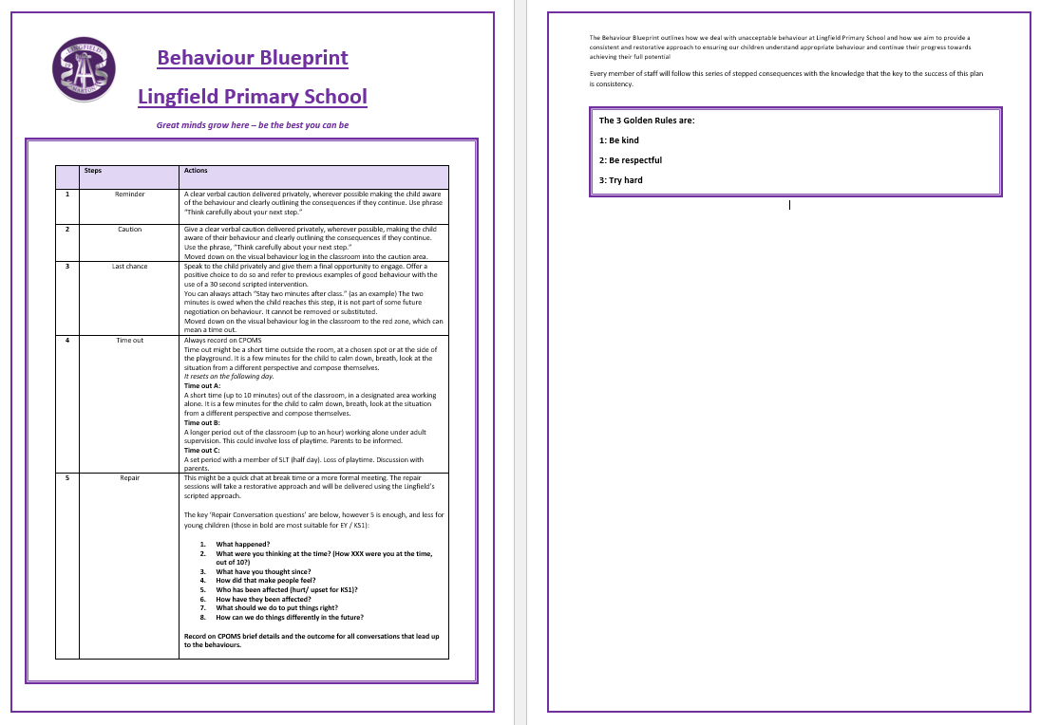
Consistent School Routines

Arrival
- Children will always be greeted by an adult at the external door and upon entering the classroom door.
- Staff will always remember that they are there to welcome the children first – before the adults, speaking directly to every child – welcoming them to the day. Children may choose to say hello, hug or smile at the adult – but the adult must make every effort to interact with every child, setting the tone for the day.
- Children will always know ‘what to do’ when they enter the classroom – once their coat is hung up, children should have an activity to settle down to before the day starts.
- Adults in the room should use this time to ‘check in’ with children – particularly those who may be most vulnerable.

Moving Around School
- The way that children move around the building and ‘carry themselves’ says so much about the expectations of the school. Get this right, the learning will transcend long beyond school and in to adult life.
- Sensible Walking relates to the school virtue of respect: self-control and independence – we expect children to walk well independently of adult supervision.
- Walking confidently and with purpose is taught and expected, following these key points
- Shoulders back
- Head held high – I am proud to be me!
- Hands by their side – not in pockets
- We do not slide and lean along walls, or touch things as we walk past – we have self-control
- We smile and greet people in our path
- We hold doors open and articulate ‘after you’
- We always walk on the right-hand side

Our Lining Up

- The children are taught how to line up smartly, sensibly and in a straight line. In EYFS and KS1 teacher at the front and TA at the back, stopping at key points to reinforce
- In ‘line-up’ order (staff have created line up orders)
- Quietly
- Join by walking to end of line – no running or pushing in
- Leave enough space
- Sensible Walking!
- We do not touch anyone or anything - we have self-control
- We hold doors open
- We always walk on the right-hand side

At outdoor playtimes
- The children are taught how to line up smartly, sensibly and in a straight line.
- The whistle goes, children stop.
- When the whistle blows again, children walk to their line up area

Staff lead children from the classroom to the playground, with the exception of Year 6 as they are trusted to develop independence to follow the school rules. The children are then collected from the playground and are positioned in key points around the school to welcome children back into school and into their classroom.

Carpet Expectations

- Sit on your bottom with your legs crossed
- Hands on your laps
- Show me good listening
- Eyes on the speaker
- Give eye contact to whoever is talking
- Show me you are ready to learn
- Stand up
- Walk to tables
Getting Attention

Consistency through school is important, therefore the adopted process is
- Sleigh bells ring
- 3 Give Me your Attention
- 2 Empty hands, silent voices
- 1 Look at the speaker

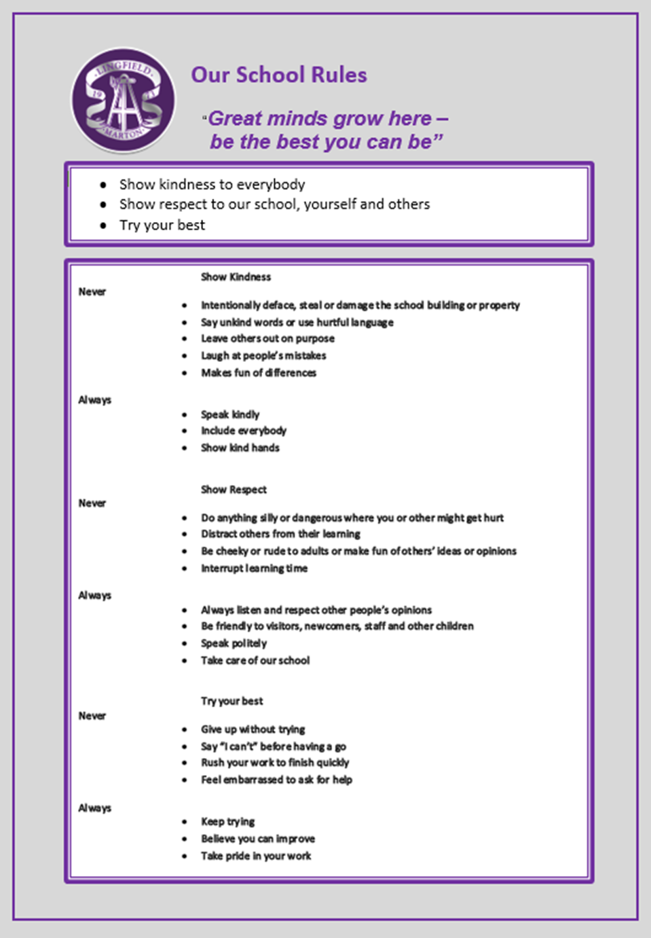
De-escalation Techniques

Tool box to support de-escalation techniques

Fresh face | Move back out of immediate range and let other staff/pupils become the focus
Reassurance | “I’ll always try to be here if you need me”  “Although that was wrong, we can help you put things right again”
Success reminder | “Remember that excellent number work you did for me this morning…”
CALM talking | In any potential confrontation, the first person who needs to calm down is the responsible adult.  Staff must maintain personal control.  Lower voice to help show that you are in control.
Distraction | Talk about something totally different (i.e. next weekend) to the child, or to another person.  Bring in something personal such as, “When I was talking to your mam on the phone…”  “Did you see East Enders last night?”  “Would you like a drink of water?”
Contingent touch | Sometimes a gentle touch on the forearm, hand, shoulder, etc works wonders. Any specialised touch or stroke needs to be formalised in the pupil’s Care Plan and signed by parent.
Reflective listening | “Focus on ‘feeling’ words….  - Note general content of message  - Observe body language  - Ask yourself, “If I were having that experience right now, what would I be feeling?”  - Reflect meanings. “You feel….because…
Humour | “Did you hear the one about….” Knock knock..
Planned Ignoring | If it isn’t upsetting anyone else…  Give a child ‘quiet time’ with no interaction other than reflection
Withdrawal offered | “Why don’t you go and finish that work in the library…”
Antiseptic Bounce | Message with ‘AB’ written at the top – this gives the child time out
Emphasise concern for welfare | “Are you alright? … Show me that hurt finger…oooh that must hurt a lot… Did you have a nice tea last night?
Help Script | ‘’Name’, I can see you’re upset/ angry …I’m here to help. Come with me. You talk, I’ll listen ‘’

Pupil Behaviour, Positive Handling and Risk Assessment

Education Establishment  Lingfield Primary School | Assessor/Role
Name of pupil and D.O.B | Reason for Assessment | Date Reviewed

Diagnosis:

Pupil Profile | Always | Sometimes | Comments
Comprehension/Communication
Age appropriate
Limited/delayed
Compliance: |  | Details
Co-operative
Un Co-operative
Unpredictable
Positive handling needed
Behaviours: |  | Details
Verbal abuse
Threatening behaviour
Physical assault
Vandalism
Absconding
Theft
Defiance
Persistent disruptive behaviour
Unacceptable language
Other behaviours: |  | Details
Emotional/physical issues: |  | Details
Sensory issues
Anxiety/Emotional State
Meltdowns/Tantrums
Hypermobility
Fine/Gross Motor skills

Recommended Strategies:
Verbal Advice | Reassurance | Time Out Offered | Another Classroom | Negotiation
Step Away | Success Reminder | Distraction | Contingent Touch | Planned Ignoring
Humour | Fresh Face | Choices | Consequences | Reflective Listening
Space given | Antiseptic Bounce | Peer Mentor | Other (state)

Has a behaviour plan been completed? | Yes/No | Comments

Preferred Supportive Strategies
Verbal advice & support – using visuals |  | Contingent touch
Reassurance |  | Planned ignoring
C.A.L.M talking & stance |  | Time out offered
Time out directed |  | Fresh face
Humour |  | Choices/Limits/Consequences
Negotiation |  | Space given
Step away |  | Reflective listening
Success reminder |  | 3 part assertive message
Distraction (key words/objects/likes) |  | Antiseptic bounce
Brief description of supportive strategies e.g agreed use of language/consequences etc.

Preferred Handling Strategies (where necessary)
Caring C |  | Wrap hug Standing/Seated
Friendly hold |  | Double elbow standing/seated
Single elbow standing/seated |  | Half shield
Figure of four

Stepped Behaviour Strategies – Avoiding Escalation
Behaviour | Comments/Recommended Strategies | Level of risk to self- details  Low, Medium, high | Level of risk to peers- details  Low, Medium, high | Level of risk to staff- details  Low, Medium, high
DATE OF NEXT REVIEW:

SIGNED ASSESSOR: SIGNED LEADER:

SIGNED PARENT: DATE:

