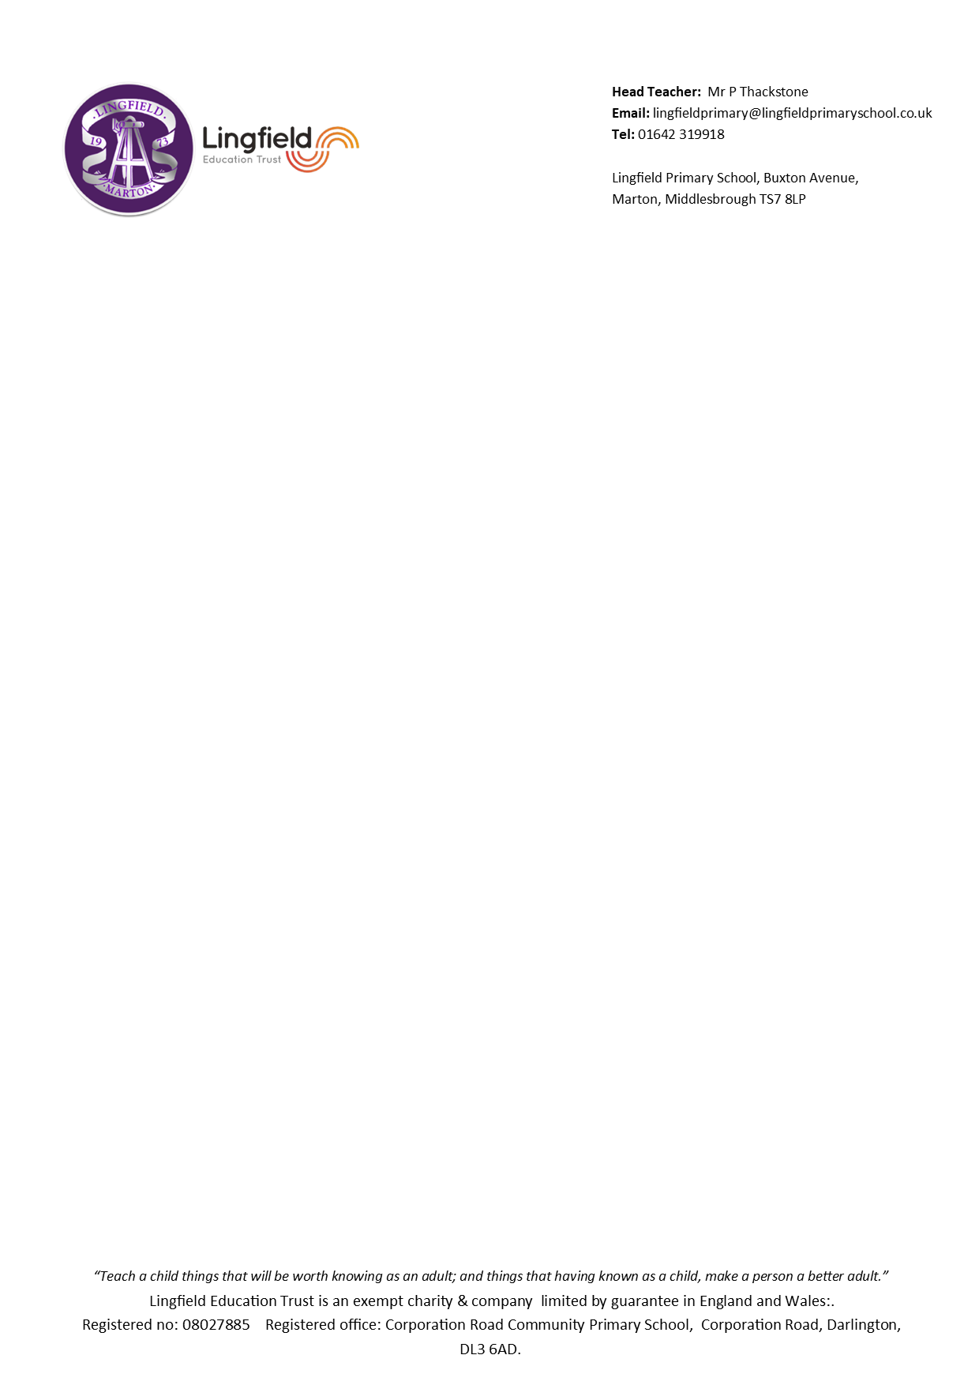
Head Teacher- Mrs N Padgett
Email- lingfieldprimaryschool@lingfieldprimaryschool.co.uk
Tel: 01642-319918

Lingfield Primary School, Buxton Avenue,
Marton, Middlesbrough, TS7 8LP
Dear parents and carers,
A very warm welcome to Year 2! I hope to make your child’s final year in KS1 an exciting and enjoyable one, as well as supporting and moving them forwards on their learning journey.
This term in Maths we will be looking at numbers up to 100 as we explore Number and Place Value and improving our addition and subtraction skills. It is really important that children learn their add and take facts off by heart. We will continue to have daily Mastering Number sessions to support this but in addition, it would be great if they could practise at home using NumBots or Hit the Button.
In English the children will continue to work on their phonics alongside their other reading skills such as retrieval and inference. We will be reading a range of exciting stories, poems and non-fiction books to help us improve our understanding of different texts. In writing, we will be exploring instructions, poems and character and setting descriptions.
Rather than teach a topic this term, we will instead be teaching subjects separately. In Geography we will be asking the question, ‘Where in the world do we live?’ and in History we’ll be thinking about the life of Captain James Cook. R.E. will see us exploring what Hindus learn from the story of Rama & Sita and asking why Christians believe God gave Jesus the world. To develop our creativity, we will be exploring painting and mixed media in Art, looking at pneumatics in D.T. and improving our vocal and instrumental range through in Music. In P.E. this term, we will work on fitness, tag rugby, gymnastics and hockey. Our e-safety, coding, publishing, presenting, film making and sounds production skills will be developed in Computing and in PSHE we will be thinking about what it means to be ourselves and how to celebrate difference. By Christmas, I think we’ll all need a rest!
Weekly spellings will be given out on a Monday and tested the following Monday. Spellings will be given out on paper and sent home with your child. In addition to this, we ask that your child work on Numbots 2-3 times per week and read at home 3 times per week for 10-15 minutes. We will monitor this through reading records and the NumBots website.
P.E. will take place on Monday mornings and Wednesday afternoons. Children will need to come to school in their P.E. kit on these days and, as we will aim to have most of our lessons outdoors, please be mindful of this as the weather gets colder.
If you have any worries or concerns this year, please don’t hesitate in coming to see me. Thank you for your continued support.
Mrs Park

